**Case Study: Diagram Drawing Application**

**Student Handout**

1. **Overview**

The learning object of this case study is for student to have a hands-on experience on a relatively complex system build in the OOP way, understand the design and construct of the system, self-learn the usage of an unfamiliar Java library, and combine their OOP knowledges to finish the system.

For this case study, you will receive a source code of a half-completed diagram drawing application. The half-completed application only has two available function: drawing lines and drawing Pie charts. For other functions, only a framework of the code is given, and these functions are currently uncompleted and unavailable.

1. **Application Introduction**

The application has a GUI for your use. It starts with the main menu page as shown on the right, you can choose to start drawing figure or diagram, or choose exits to stop running.

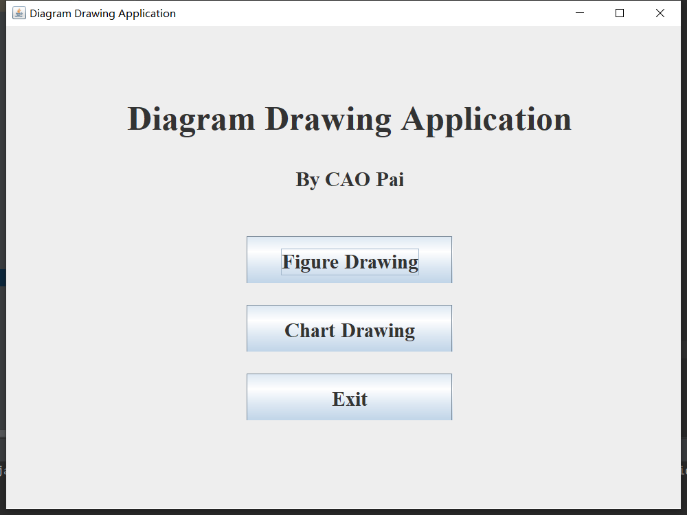

1 Main Menu Page

If you click the “Figure Drawing” button in the main menu, a drawing board will shows as shown below. You can choose from the menu bar to clear the drawing board, back to main menu, or choose between drawing lines or rectangle. The you can draw figures with your mouse on the board. You can also choose the select option to click on a figure on the drawing board, the select figure will shown as red. You can move the selected figure by dragging with the mouse, or delete the selected figure by pressing “Delete” on keyboard.

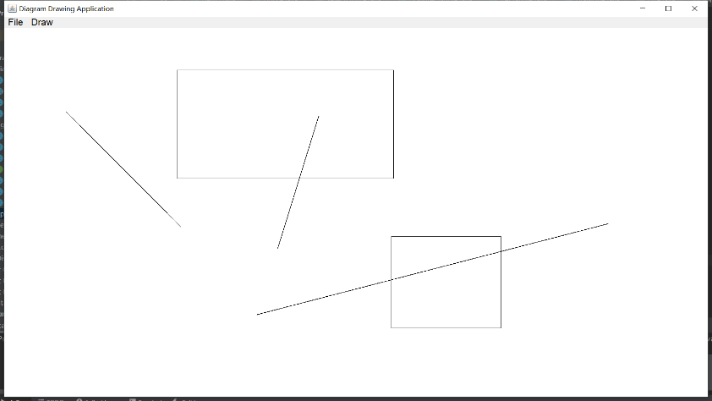

2 Figure Drawing

If you click the “Chart Drawing” button in the main menu, you will come to the diagram drawing page as shown to the right. To draw a diagram, you should first choose a diagram type from the ComboBox, then click the “Draw” button. A window will appear for you to input the file name for the data, then a diagram with the type you chose and the data in the file you input will be displayed. Click “Back” to return to main menu.

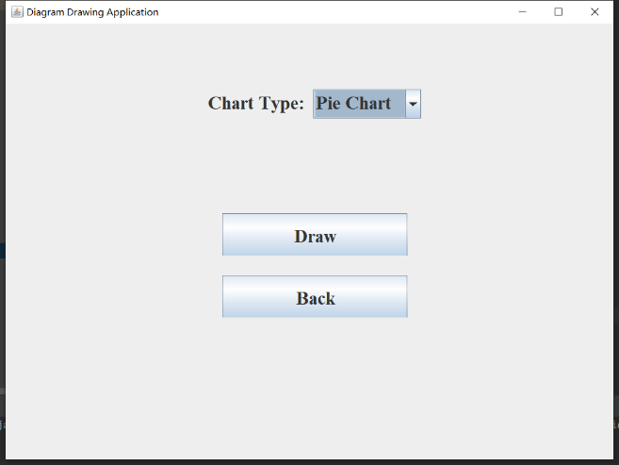

3 Chart Drawing

For different chart, the data in the .csv file require different format. In the zip file you download, three sample data files are given for each type of chart. “Grade Distribution.csv” for pie chart, “Student Grade.csv” for bar chart and “Student Performance.csv” for line chart. For drawing pie chart, the data have two columns, the first column is the category, the second column is the total number or percentage of each category. For drawing bar chart and line chart, the data have three columns. The first and second columns are two group of categories, and the third column is the value. See sample data files as examples.

1. **Installation Guide**

Download the file “COMP2021 Case Study” from Blackboard. Unzip the file. The project of the diagram drawing application is in the folder “COMP2021_CaseStudy”, open it with IntelliJ IDEA.

To use the library JFreeChart, first, unzip the file “jfreechart-1.0.19.zip”. in the IntelliJ IDEA, choose File-Project Structure-Project Setting-Modules, and add “jfreechart-1.0.19.jar” and “jcommon-1.0.23.jar” in the folder “lib” to the project dependency. Then the drawing pie chart should be able to execute without error.

1. **Tasks Description**

You are expected to finish two tasks of this case study: finish the application and write a report.

**Part A:**

For the part “Figure Drawing”, you are expected to try the function of drawing lines, select functions and read the source code implementing all these functions around drawing lines. Based on these preparations, you should finish the rectangle class and function of drawing rectangle by yourself, and achieve same performance on drawing, selecting, moving and deleting on rectangles as on lines. The contents that you need to finish for this task are in files “Rectangle.java”, “DrawRectangle.java”, “Figure.java” and “SelectFigure.java”. The part you need to implement are marked by annotations.

**Part B:**

For the part “Chart Drawing”, you should self-learn the usage of the Java library “JFreeChart” and the code of drawing pie chart. And use the knowledge to finish the code of drawing bar chart and line chart. The finished application should be able to draw bar charts and line charts with input .csv files. The contents that you need to finish for this task are in files “BarChart.java” and “LineChart.java”. The part you need to implement are marked by annotations. You can also create your own dataset for testing.

**Report:**

For the report, each student should write a report for no more than 800 words. Describing your implementation, summarizing you understand and reflection of the case study.

**Bonus:**

There are two bonus tasks that are optional for you to finish:

1) Implement the “undo” function in figure drawing that support to undo the latest operation including drawing, deletion and moving on figures.

2) Extend the select function to make it able to change the shape of selected figure by dragging one of the endpoints by mouse.

You are allowed to change the given parts of code to achieve the bonus functions. The bonus point of the two bonus tasks can be stacked but the total score with bonus point addition will not exceed 100%.

1. **Submission**

Archive your whole project into a ZIP file, as well as the report in PDF. Submit the ZIP file on Blackboard before the deadline. If you use other IDEs for your development, make sure your project is put into an IntelliJ IDEA project that is ready to be executed.

1. **Source for Reference**

JFreeChart Mainpage: <https://www.jfree.org/jfreechart/>

JFreeChart on Github: <https://github.com/jfree/jfreechartv>